Assignment –

Your company has an existing legacy system for employees to submit booking requests for meetings

in the boardroom. The system keeps the requests in a text file (format below). Your employer has

now asked you to implement a system for processing batches of booking requests. And you need to

expose a REST api that will accept the text input (in header ) and process them based on the booking rules and

returns a structured json response as below.

Your processing system must process input as text. The first line of the input paylod

represents the company office hours, in 24 hour clock format (ignore timezones), and the

remainder of the input represents individual booking requests. Each booking request is in

the following format:

[Request submission time, in YYYY-MM-DD HH:MM:SS format] [Employee id]

[Meeting start time, in YYYY-MM-DD HH:MM format] [Meeting duration in hours]

**A sample text input follows, to be used in your solution:**

"0900 1730\n2020-01-18 10:17:06 EMP001\n2020-01-21 09:00 2\n2020-01-18 12:34:56 EMP002\n2020-01-21 09:00 2\n2020-01-18 09:28:23 EMP003\n2020-01-22 14:00 2\n2020-01-18 11:23:45 EMP004\n2020-01-22 16:00 1\n2020-01-15 17:29:12 EMP005\n2020-01-21 16:00 3\n2020-01-18 11:00:45 EMP006\n2020-01-23 16:00 1\n2020-01-15 11:00:45 EMP007\n2020-01-23 15:00 2"

**If we remove the line separator it will look like this :**

0900 1730

2020-01-18 10:17:06 EMP001

2020-01-21 09:00 2

2020-01-18 12:34:56 EMP002

2020-01-21 09:00 2

2020-01-18 09:28:23 EMP003

2020-01-22 14:00 2

2020-01-18 11:23:45 EMP004

2020-01-22 16:00 1

2020-01-15 17:29:12 EMP005

2020-01-21 16:00 3

2020-01-18 11:00:45 EMP006

2020-01-23 16:00 1

2020-01-15 11:00:45 EMP007

2020-01-23 15:00 2

2. Output

Your system must output a list of bookings in a specific format; with booking grouped

chronologically by day. For the sample input displayed above, your system must provide the

following output

[

{

"data": "2022-11-07",

"bookings": [

{

"emp_id": "EMP001",

"start_time": "09:00",

"end_time": "11:00"

}

]

},

{

"data": "2020-01-22",

"bookings": [

{

"emp_id": "EMP003",

"start_time": "14:00",

"end_time": "16:00"

},

{

"emp_id": "EMP004",

"start_time": "16:00",

"end_time": "17:00"

}

]

},

{

"date": "2022-11-07",

"bookings": [

{

"emp_id": "EMP007",

"start_time": "15:00",

"end_time": "17:00"

}

]

}

]

3. Booking rules

- No part of a meeting may fall outside of office hours (9:00 to 18:00).

- Meetings may not overlap.

- The booking submission system only allows one submission at a time, so submission

times are guaranteed to be unique.

- Booking must be processed in the chronological order in which they were submitted.

- The ordering of booking submissions in the supplied input is not guaranteed.

Solution : Using REST API

EndPoint - http://localhost:8080/meetingRequest

Project Structure:

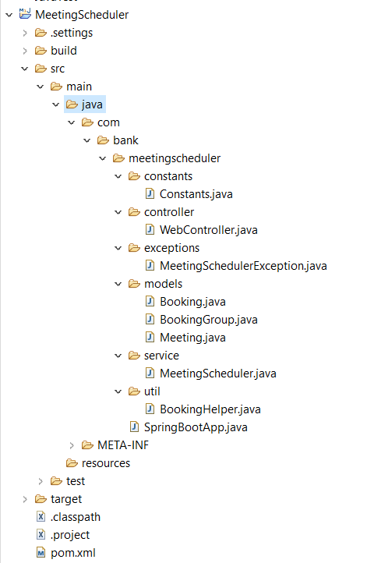

Started application as SpringBoot

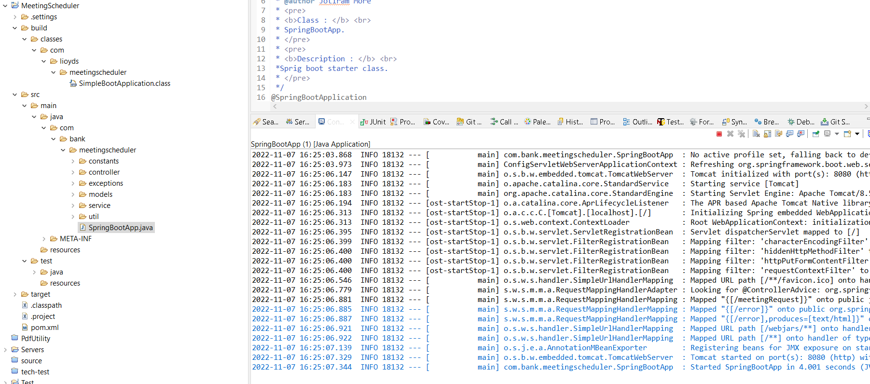

Passed string as line seperator :

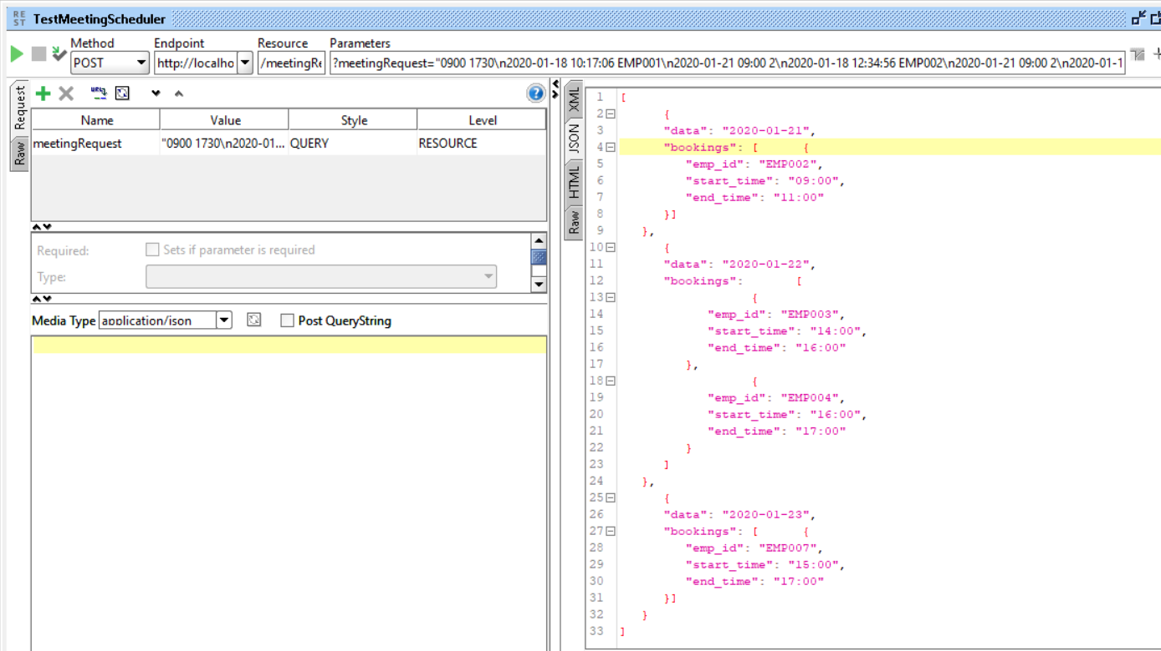

Error when Empty String or null is passed :

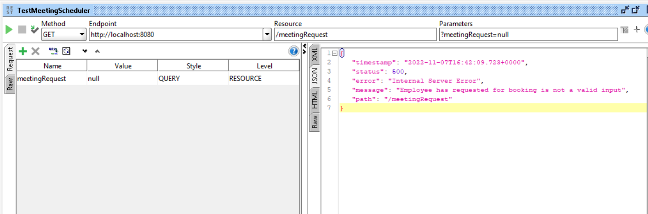

Error when only one date is passed and that is to Out of Office hours :

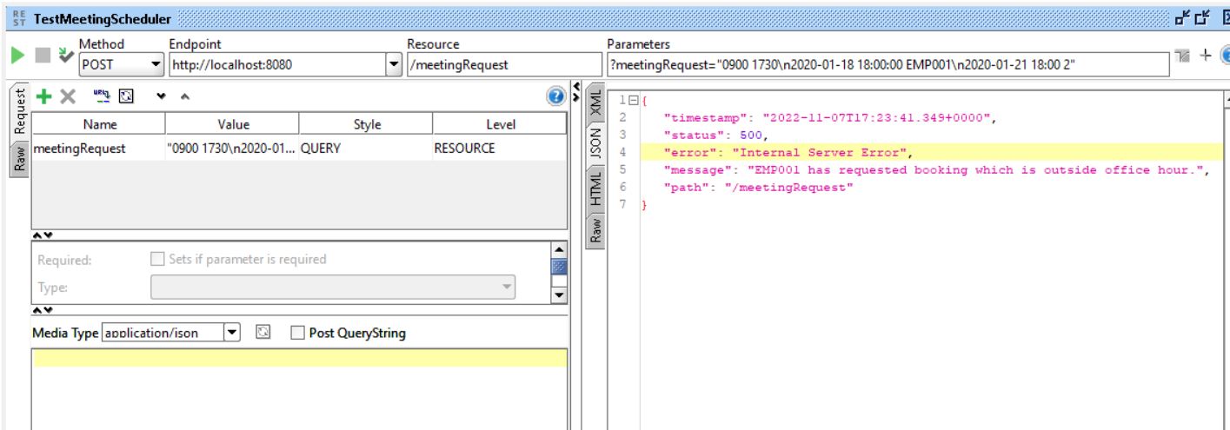

Junit :

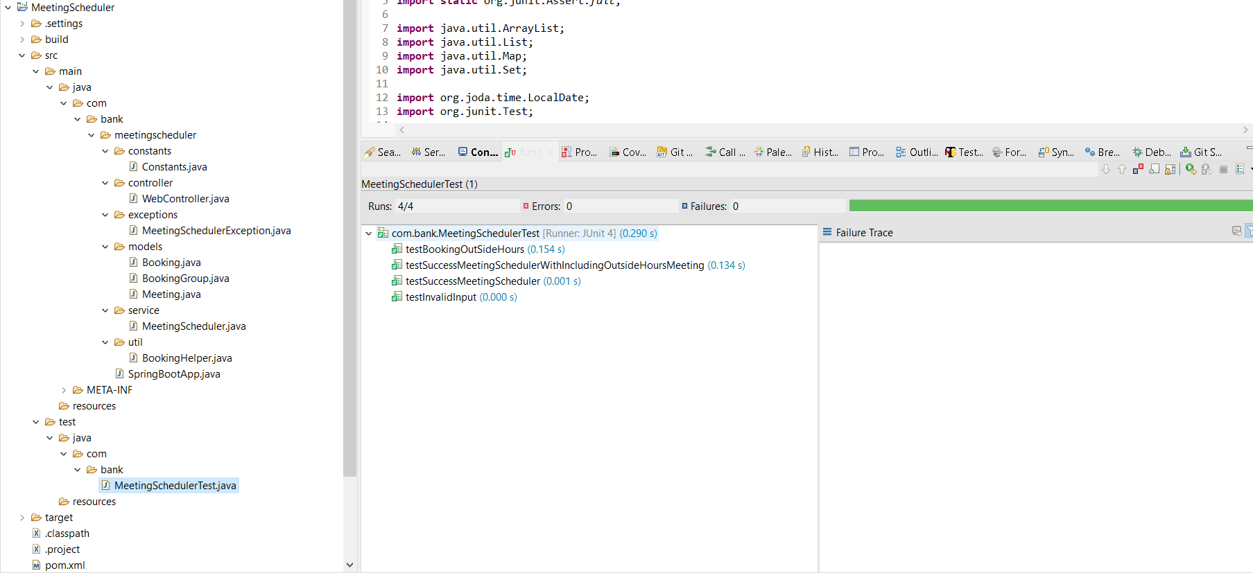

Code Coverage :

